**DATE FOR YOUR DIARY**

**FRIDAY 29TH SEPTEMBER 2023 at 7pm**

**STARS IN THEIR EYES**

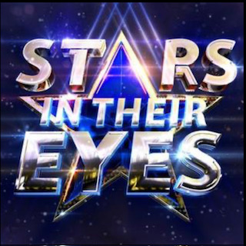

**Pillars of St. Michael’s** are putting on Betchworth’s answer to the TV favourite – **Stars in Their Eyes** – an evening of karaoke. Come and cheer our brave contestants on.

The evening will be held in the Village Hall at **7 pm** and will begin with supper followed by the evening’s entertainment. We already have some talented entrants but room for more. The play list is huge and we’re hoping for a real performance not just a tribute to the original performer. We know what a lot of star quality there is in the village so come on don’t be shy. Phone for more information if you want to talk it through.

Tickets are £27 each, which will include supper. There will be a pay bar available

Why not get a table together with your friends ……..tables of 8 are preferable.

**Milla Peterken camillapeterken@gmail.com**