

BETCHWORTH PARISH COUNCIL
BURIAL GROUND POLICY AND REGULATIONS

INDEX
- Introduction
- Legal Framework
- Definitions
- General Regulations
- Exclusive Rights of Burial
- Graves and Ashes Plots
- Memorials
- Flowers and Plants
- Parishioner Status
- Charges
- Burial Ground Capacity
- Feedback and Complaints
- Records and Reporting
- Appendices

1. Introduction
The Betchworth Parish Council Burial Ground (“the Burial Ground”) is a rural lawn cemetery situated adjacent to the Churchyard, with views across the surrounding countryside and towards Betchworth. It is accessed via a dedicated pathway running north from the Greensand Way.
The Burial Ground comprises:
- Consecrated ground
- Unconsecrated ground
- Designated areas for the interment of ashes

The Burial Ground is owned and managed by Betchworth Parish Council. Although located close to Betchworth Church, it is not associated with the Church and is open to persons of all faiths or none.
The Burial Ground is primarily intended for the use of parish residents. It is maintained as a smart rural lawn cemetery designed to provide a peaceful, dignified and respectful environment.
All visitors are expected to respect the tranquillity and integrity of the site at all times.

2. Legal Framework
These regulations are made by Betchworth Parish Council under the powers conferred by:
- Local Government Act 1972
- Local Authorities' Cemeteries Order 1977 (LACO)

The Council reserves the right to amend these regulations as necessary to ensure proper management of the Burial Ground.

3. Definitions
For the purposes of this Policy:
- “The Council” means Betchworth Parish Council.
- “The Burial Ground” means the Betchworth Parish Council Burial Ground located west of The Walled Garden in Betchworth.
- “Grave” means the burial space formed in the ground by excavation.
- “Grave Space” means the area formed by the grave and memorial.
- “Grave Plot” means the designated area containing a grave and memorial, including surrounding spacing.
- “Exclusive Right of Burial (ERB)” means the exclusive right to burial in a specified grave space for a period of 50 years.
- “Deed of Grant” means the document issued by Betchworth Parish Council, confirming the purchase of the ERB

4. Exclusive Rights of Burial
4.1 Grant of Rights
Exclusive Rights of Burial may be purchased for:
- Full grave plots
- Ashes plots
Rights are granted for 50 years on a “next available” basis.
4.2 Use of Grave Spaces
- Maximum of two coffin interments per grave plot (subject to depth and water table conditions).
- Up to four interments of ashes per full grave space.

4.3 Transfer of Rights
The ERB forms part of the owner’s estate and must be transferred through:
- A valid Will
- Grant of Probate
- Letters of Administration
- Statutory Declaration
The Deed of Grant must be produced before memorial works or further interments are permitted.
4.4 Change of Address
ERB holders must notify the Council of any change of address, email address or phone number.
4.5 Re-purchase by the Council
The Council may re-purchase an unused grave space at the original purchase price (pro-rata for remaining lease term), less an administrative fee as published on the Council website.

5. Graves and Ashes Plots
5.1 Dimensions
- Adult grave plot: 8ft x 4ft
- Grave space: 6ft 6in x 2ft 6in
- Ashes plot: approximately 3ft x 3ft
- Ashes space: 2ft x 2ft

Coffins must be buried:
- No less than 3ft below ground level
- No deeper than 7ft

Due to the water table, no more than two coffin interments are permitted per grave.

‘Grave space’ means the space formed by the grave and the Memorial.

‘Grave Plot’ means the designated area containing a grave and memorial, including surrounding spacing.
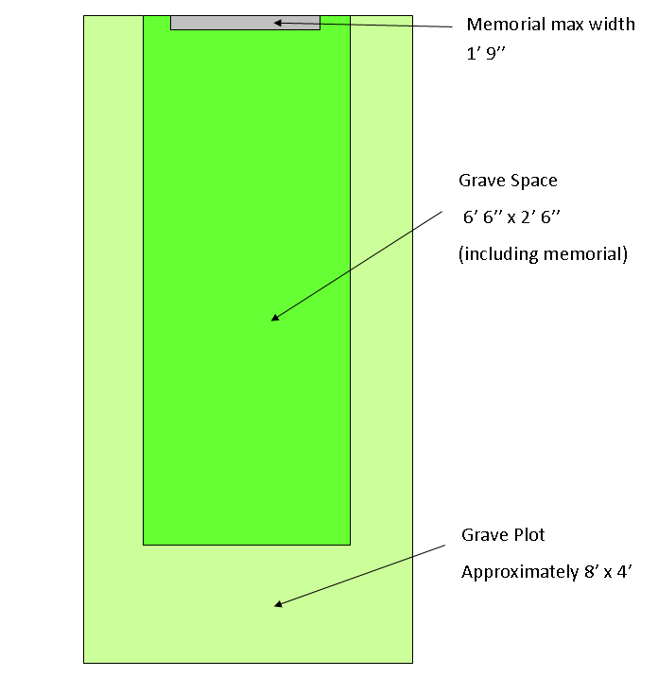
5.2 Plans and Records
Grave sections are marked on official plans maintained in accordance with LACO requirements. Coffin dimensions must be compatible with the standard grave space unless prior approval is obtained.
5.3 Ground Restoration
All graves will be levelled and grassed by the Council approximately 12 months after burial.
5.4 Rights of Access
The Council reserves right of passage over all graves for maintenance and operational purposes.

6. Memorials
6.1 Prior Approval
All memorials, including inscriptions, any modest relief motif, design and materials, must be approved in writing before orders are placed.
6.2 Permitted Materials and Finish
Memorials must:
- Be constructed from natural light stone or hardwood
- Have a matt or honed finish
- Blend with the rural setting
- comply with BS 8415-2018 and NAMM Code of Working Practice.
Acceptable examples include Portland limestone, York stone and Nabresina limestone.
6.3 Dimensions
Maximum dimensions:
- Height: 762mm (2’6”)
- Width: 533mm (1’9”)
Existing memorials do not set precedent.
6.4 Inscriptions
Permitted:
- Plain cut lettering
- Black enamel or lead-filled lettering
Not permitted:
- Gold, silver or coloured lettering
- Portraits
- Non-traditional shapes (e.g. hearts, statues)
- Highly Polished finishes
- Red, black or dark grey stone
- Granite or slate in dark or coloured form
- Kerbing or full flat ledgers
- Synthetic materials
- Pure white marble

Kerbing memorials and full flat ledgers previously permitted are no longer permitted for Health and Safety and maintenance reasons. Designs that currently exist, do not set a precedent for new applications.

6.5 Examples
Examples of accepted designs:
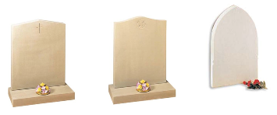
Examples of non acceptable designs:
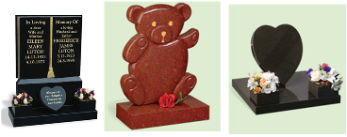
6.6 Installation
Memorials:
- must meet British Standard BS 8415 and use qualified masons registered with BRAMM or NAMM to ensure safety and durability
- May not be installed within six months of burial
- Must be erected by approved memorial masons
- Remain the responsibility of the applicant
The Council is not liable for damage howsoever caused.

6.7 Safety Inspections
Memorials will be inspected at least every five years. Unsafe memorials may be made safe, laid flat or otherwise secured if not remedied within one month of notification.
7. General Regulations
7.1 Prior Permission
No works may be undertaken in the Burial Ground without prior written permission from the Council.
Permitted working hours:
- Monday to Friday: 9:00am – 5:30pm
- No works permitted on Sundays or Public Holidays

7.2 Notice of Interment
Notice of interment must be submitted on the Council’s prescribed form, accompanied by the appropriate fee and application for a Deed of Grant.
7.3 Funeral Arrangements
The person arranging the funeral is responsible for all arrangements with the officiant. All internments must be undertaken by a Council approved Funeral Director.
7.4 Documentation
The Registrar’s Certificate for Disposal or Coroner’s Order (where applicable) must be produced to the Council at the time of interment.
7.5 Public Safety
Visitors are warned of uneven ground surfaces. Dogs must be kept on a lead at all times
8. Flowers and Plants
- No planting or garden areas permitted.
- Maximum two free-standing pots per grave (max 6 inches).
- Natural flowers only.
- No glass containers.
- No plastic or silk flowers.
There are no litter bins on site; all waste must be removed by visitors.
The Council reserves the right to remove non permitted gardens, items and deteriorated items.

9. Parishioner Status
The Burial Ground is primarily for Betchworth residents.
Parishioner status applies where one of the following is satisfied:
a) Registered on the Electoral Register of Betchworth or Brockham within three years prior to death
b) Previously registered on the Betchworth or Brockham Electoral Register for 25 years or more
c) Left Betchworth or Brockham directly into care
It is the responsibility of the applicant to evidence parishioner status. Where criteria are not met, non-parishioner fees apply.
The Council may consider exceptional cases at its discretion. The Council’s decision is final.

10. Charges
Fees are reviewed annually and published on the Council website. Charges contribute to maintenance and long-term sustainability of the Burial Ground.

11. Burial Ground Capacity
The Council monitors capacity. If necessary, additional land within the Burial Ground may be allocated for burials, including land currently used for allotments.

12. Feedback and Complaints
Comments, complaints and suggestions should be submitted in writing to the Council via email BBG@betchworth-pc.gov.uk. All submissions will be reviewed and responded to appropriately.

13. Records and Reporting
The Council maintains:
- A paper Grave Register
- An electronic burial database
- An up-to-date Burial Ground plan identifying plot ID and surname
An annual review of forms, processes and compliance will be undertaken. Regular reports will be submitted to the appropriate Council Committee identifying operational updates, risks and issues.

14. Appendices
Appendix A1 – Exclusive Right of Burial Form
Appendix A2 – Notification of Burial Form
Appendix A3 – Memorial Application Form
Appendix A4 – Deed of Surrender of an ERB form
Appendix A5 – ERB Transfer of ownership / Change of details form
Appendix A6 – Current Fees Schedule

Approved by Betchworth Parish Council
Date: _13/4/26___________

